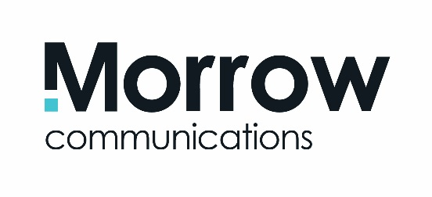

Job Description:
Graphic Designer
The Role
Morrow Communications is looking for a creative Graphic Designer, ideally with agency experience, to join our team of integrated communications specialists. The successful applicant will provide graphic design and digital content for a wide range of top brands, events and leading organisations across the UK and Ireland.
The Candidate
Having a minimum of 2 years’ experience in graphic design for advertising, print and digital platforms, you will be skilled in taking projects from creative concept through to final production. You will have the ability to liaise directly with clients, suppliers and team members in a collaborative and professional way.
Working with major and growing brands, you will be able to spot, develop and present great ideas ensuring that a high quality of creative work is delivered for clients.
You will have an impressive portfolio and be skilled in using Adobe Creative Suite including Illustrator, In Design and Photoshop. Creative ability and experience in web design, animation (After Effects or similar) or video editing (FCPX) would be a plus.
Key Skills:
- Exceptional creativity and a strong visual sense
- Excellent time management and organisational skills
- Ability to balance work on several projects at once
- Accuracy and attention to detail
- An understanding of the latest trends and their application within a commercial environment
- Confidence to present and explain ideas to clients and colleagues
- The ability to grasp client needs, consider practical solutions and take constructive feedback
- Good team-working skills
- Flexibility and a strong work ethic
- Excellent IT skills, especially with design software
Essential Criteria:
- Third level qualification in a related subject
- A minimum of 2 years’ experience in a similar role
- Exceptional conceptual and creative abilities
- Understanding of the end-to-end print design and production process
- Digital knowledge and hands-on experience in content creation
- Ability to manage your workload and meet agreed schedules and deadlines
Desirable Criteria:
- Creative ability and experience in web design/development, animation (After Effects or similar) or video editing (FCPX) will be a distinct advantage.
To Apply:
Email your current CV and portfolio to info@morrowcommunications.com before 5pm Monday 5th June 2017.

