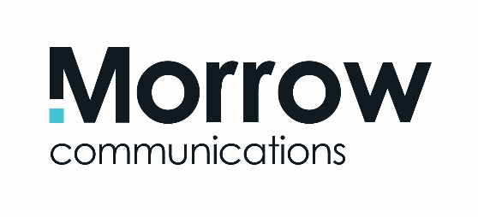

Make Our Year Your Year

Current CIPR Consultancy of the Year 2021/22 Morrow Communications is looking for a number of experienced and enthusiastic communications and digital professionals to join our award-winning PR & Communications team. We currently have a number of opportunities for Snr Communications Manager (SCM) and a Communications & Digital Executive (CDE) positions.

We are based in Holywood, County Down, and are one of Northern Ireland’s leading integrated communication consultancies, representing some of the UK and Ireland’s most exciting brands and organisations.

Our client base is growing and adapting to new challenges and exciting opportunities and so are we. We now require additional support for several of our key blue-chip accounts where digital communication is increasingly critical as part of our integrated comms solutions. Successful applicants will work as part of core client teams and bring energy and experience to the respective roles.
In return, we will offer a fast-paced, rewarding role with a competitive salary and plenty of opportunity for career growth. This will be provided in an open, friendly, and supportive environment with relevant training and professional development.

Specific experience required for each role

Applicants for Communications and Digital Executive (CDE) must have 1-2 years’ relevant PR / communications experience working with clients/organisations in the private and/or public sector.

Applicants for Snr Communications Manager (SCM) must have a minimum of five years relevant PR / communications experience working with clients/organisations in the private and/or public sector. This should include experience of devising and delivering communication strategies to meet client objectives as well as managing associated budgets.

All applicants should…
- Hold a third level qualification (preferably, but not exclusively in Public Relations, Communications and/or Marketing)
- Have a recognised digital marketing qualification and/or proven experience of designing and delivering digital communications programmes including: content planning, copy creation and delivery across a range of social media platforms; social influencer management, planning and delivering digital advertising campaigns and measuring and evaluating their effectiveness
- Demonstrate solid experience of helping deliver media and stakeholder relations strategies
- Have experience of delivering excellent results within a communications/marketing environment and as part of a team.

What we are looking for…
- You’ll be an inquisitive and strategic thinker, who takes time to understand a client’s business objectives and can help devise appropriate communications solutions to achieve them.
- You’ll also be very comfortable in the digital sphere and understand how to channel great content to online audiences and advise clients on the latest digital trends.
- You’ll know how to manage a busy schedule and thrive as part of a team.
- You’ll have first-class relationship and communication skills – able to connect positively with everyone you encounter - from clients to media, colleagues to suppliers.
- You’ll have an instinctive eye for a story alongside a flair for writing in a variety of styles online and offline with meticulous attention to detail.
- You’ll be ready to jump headfirst into the role, working on a number of major PR/communications accounts in various business sectors, as varied as agri-food, finance, retail, IT, energy, transport, manufacturing and hospitality/leisure.
Who we are…

Our 30+ strong team works together to deliver big results for our clients, combining skills in PR, Public Affairs, media relations, digital communications, event management, video production, advertising and graphic design.

We are spreading our reach on an all-Ireland and global scale – with big plans to drive our business even further forward.

Our commitment to excellence has been rewarded with the Gold Communications Management Standard, awarded by the PRCA – an industry quality mark we have now held for over 10 years. We are the only NI agency to hold this accreditation and it supports our client and colleague management systems to underpin our growth.

We’ve also recently been recognised by the Chartered Institute of Public Relations as PR Consultancy of the year for 2021/22 and picked up a total of 13 awards for our client work in this year’s awards alone.

To apply…

If you meet the above criteria and have the experience and ambition to deliver what we need, apply with an up to date and tailored CV - with particular reference and relevance to the respective job descriptions above. Please quote job reference accordingly.

Please also include a separate elevator pitch about yourself (150 words maximum) highlighting how you are the must-see candidate for the respective position. Please tailor your pitch to best demonstrate how you are right for these specific roles.

Closing date… 5pm Friday 3rd December

